Contents
Overview 1
Preparing for the event 2
Microsoft FSX Family 2
Microsoft Flight Simulator 2
X-Plane 11/12 3

Overview
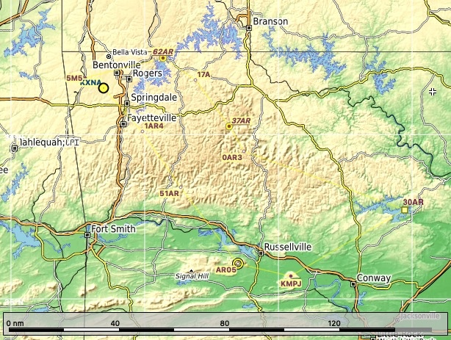
The airstrips listed in the briefing have been chosen to give an exhilarating challenge and an opportunity for an introduction/practice for typical back country flying with short take-off and landing (STOL) capabilities. Particularly suitable are taildraggers. But also ‘interesting’ navigational challenges. Some fields are not documented much if at all; some are private in real life.

Of particular interest are Byrd’s Activit Center and Banks Ranch:
- Byrd’s hosts the annual ArkanSTOL, competition. There is ArkanSTOL scenery for X-Plane and MSFS . Whilst you are there why not give their STOL course a go (https://youtu.be/Rf6aX59N_HI?si=3xGJaIVJUc36otDt).
- Banks Ranch is particularly recommended as a veritable playground of 5 challenging airstrips. It only counts as one location for the purposes of the event though!

Preparing for the event
The nature of bush flying means that some airstrips are not formally licensed and, in some cases not even officially documented. This means that depending upon your simulator you may need to do some pre-work.
All airstrips have been chosen because they are either available by default or as free add-ons in the Flight Simulators generally used by club members.

Microsoft FSX Family
All the airfields specified as usable in FSX in the briefing are available by default, so no additional work is required.

Microsoft Flight Simulator
All airstrips are available in MSFS, but the table below offers free add-ons for some of them that you might like to try.
Airstrip | Scenery
51AR Byrds | 51AR
AR05 John Harris | AR05
5M5 Crystal Lake | Comes as standard with MSFS
KMPJ Petit Jean Park | Comes as standard with MSFS
37AR Ponca International | 37AR
0AR3 Taylor’s Airstrip (Zero Alpha Romeo Three) | Comes as standard with MSFS
17A Trigger Gap | 17A
62AR Banks Ranch | 62AR

X-Plane 11/12
The default terrain in X-Plane doesn’t align with reality in the area covered by the event and to get the best experience you will need either to use AutoOrpho (or equivalent) or use Ortho4XP to download the following grid squares: +35-094, +35-095, +36–094, +36-095.
Some of the airstrips involved in the event require free add-on’s to be downloaded. The table below gives links for X-Plane 11 and X-Plane 12. As always, please pay careful attention to the library requirements of the add-ons to avoid errors on start-up.
Airstrip | XP12 | XP11
51AR Byrds | 51AR XP12 | 51AR XP11
AR05 John Harris | Comes as standard with X-Plane | Comes as standard with X-Plane
5M5 Crystal Lake | Comes as standard with X-Plane | Comes as standard with X-Plane
KMPJ Petit Jean Park | Comes as standard with X-Plane | Comes as standard with X-Plane
37AR Ponca International | Fly Ozarks | Fly Ozarks
0AR3 Taylors Airstrip | Comes as standard with X-Plane | Comes as standard with X-Plane
17A Trigger Gap | 17A XP12 | 17A XP11
62AR Banks Ranch | Fly Ozarks | Fly Ozarks

